NCIOWLClsesTab – An NCI Extension to Protégé/OWL

How to Install the NCIOWLClsesTab Plug-in
Assume that you have already installed Protégé and OWL Plug-in on your computer. The NCIOWLClsesTab plug-in has been tested to be compatible with Protégé Build 201 and OWL Build 137.
Step 1. Unzip nciextension.zip to the Protégé installation (root) directory.
Step 2. Go to Start->Programs->Protégé 2.1 beta-> Protégé. Right click on Protégé. The following Protégé Properties dialog box will appear. Change the Target field (Protégé shortcut) to the full path name of run_protégé.bat in the Protégé installation directory.
Step 3. Edit the property file, nci.properties, in Protégé installation directory as appropriate (for example, change user name, user role, or journal file name).

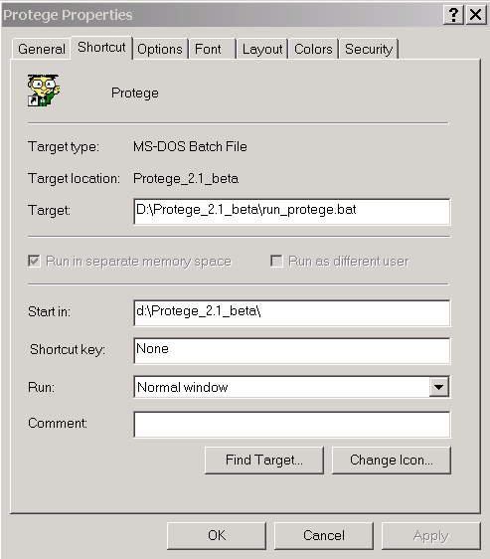

How to Set Up mySQL Database

Step 1. Download MySQL 4.0, unzip it, and run Setup.
http://dev.mysql.com/downloads/mysql/4.0.html

Step 2. Go to "%mysql_home%\bin" and run "mysqld-nt -install".

Step 3. Start the MySQL Service.
On Win2000: Go to Start->Control Panel->Administrative Tools-Services. Double-click on the MySQL service, and click on the Start button.

Step 4. Set the Root MySQL password.
Goto "%mysql_home%\bin", run the command "mysqladmin -uroot password NEW-PASS" where NEW-PASS is your password of choice.
Note: Don't type the quotes.

Step 5. Verify MySQL is running correctly.
Run "mysql -uroot -p". Enter in whatever you typed for NEW-PASS. You should see a "mysql>" prompt. Enter the command "show databases;" and hit Enter.
mysql> show databases;

Step 6. Setup a database using the following commands. Here OCI is a database name.
mysql> CREATE DATABASE OCI;
mysql> USE OCI;

Step 7. Create a new user, grant rights, and set password.
mysql> grant select, insert, update, delete on oci.* to 'ociuser'@'localhost'
identified by 'useoci' with grant option;

Step 8. Create the history table
mysql> create table history(
HISTORYID MEDIUMINT NOT NULL AUTO_INCREMENT,
CONCEPTCODE varchar(10),
CONCEPTNAME varchar(30),
ACTION varchar(10),
timestamp TIMESTAMP,
EDITNAME varchar(20),
HOST varchar(30),
referencecode varchar(10),
constraint pk_history primary key (HISTORYID)
);

Step 9. Use the exit command to exit mySQL.
How to Use NCIOWLClsesTab Plug-in

Step 1. Start NCICodeGenerator Server using the DOS batch file runServer.bat. The file can be found in the NCICodeGenerator subdirectory.
Step 2. Start Protégé using the DOS batch file run_protege.bat.
Step 3. On the Protégé dialog box, choose OWL Files and press the Build button.

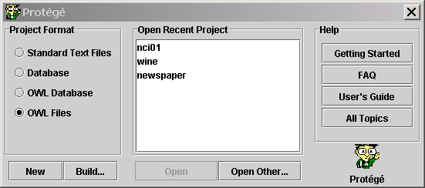

Step 4. On the OWL Files dialog box, select the sample data file, nci01.owl. The file can be found in the examples subdirectory. This file is created for demonstration purpose only. It contains a small segment of NCI.owl. The data contained in this file are not complete. Some classes do not have id and code.

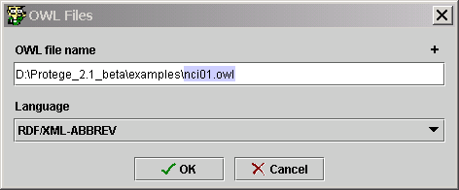

Step 5. Wait for the main window of Protégé to appear. Select the Project-Configure… submenu. The Configure dialog box will appear. Check the NCIOWLClsesTab check box and uncheck OWLClsesTab. Use the up arrow icon to move the NCIOWLClsesTab check box to the top as shown below. Press OK to close this dialog box.

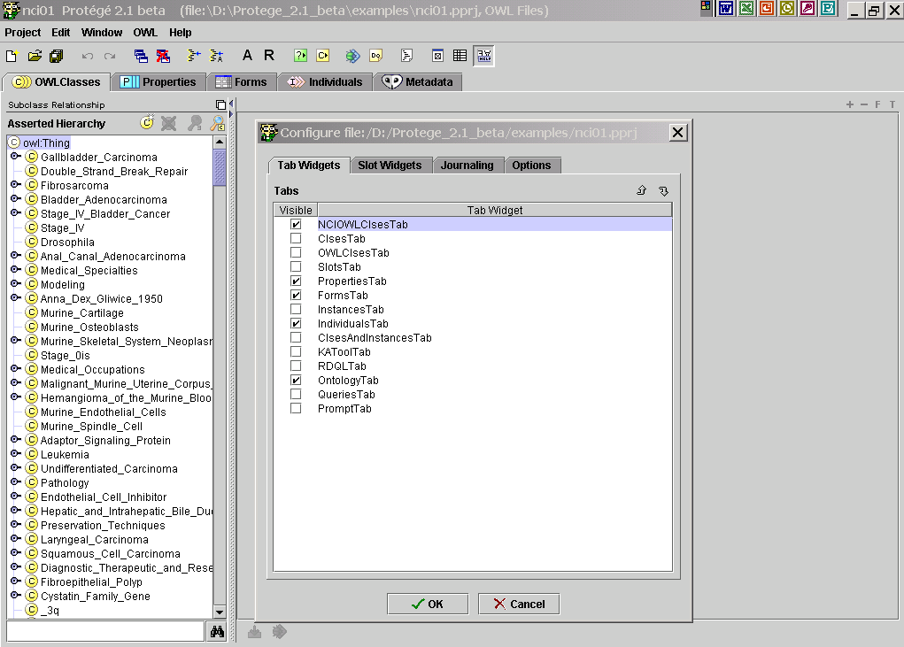

Step 6. When you press the OK button on the Configure dialog box, the following window appears. Depend on the user’s role given in the nci.properties property file, the Delete button on the Asserted Hierarchy (i.e., the taxonomy tree ) pane may be disabled.

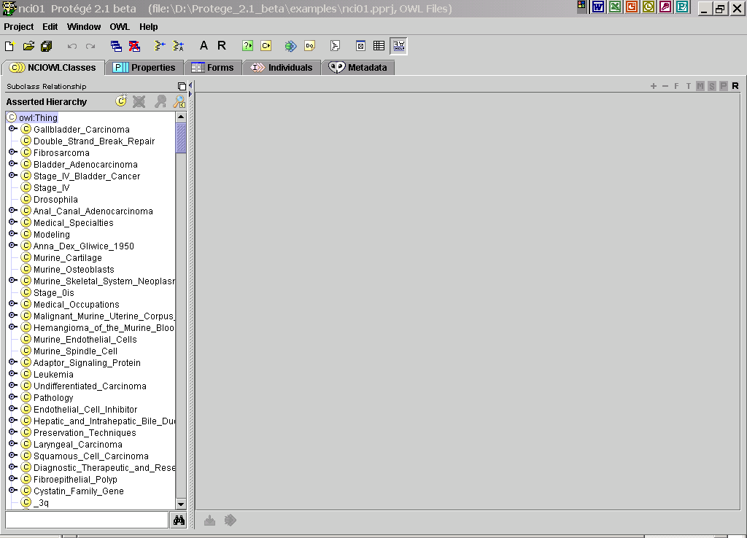

Step 7. To test the Split function, first select a class from the taxonomy tree on the left, say, Dental_Epidemiology. Click on the Split (S) icon and the following Split dialog box will appear. The left panel contains data for the existing class you have just selected. The right panel contains the new class. The default name for the new class would be the concatenation of the selected class name, the string “_split_”, and the code generated by the NCICOdeGenerator for the new class. In this case it’s Dental_Epidemiology_split_C27353. You may not see the same code because the state of the NCICodeGenerator may not be identical to the one used here. The new class will have the same properties the existing class has with the exception of the new id and code annotation property. You may edit properties of any of these two classes as needed using the existing capabilities provided by Protégé/OWL. Press Split to continue; or press Cancel to close the dialog box.

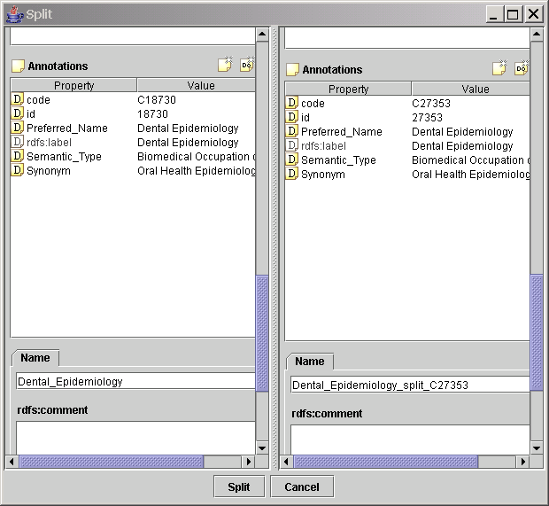

When you press the Split button, the Split dialog will be closed and you should be able to find the new class in the taxonomy tree.
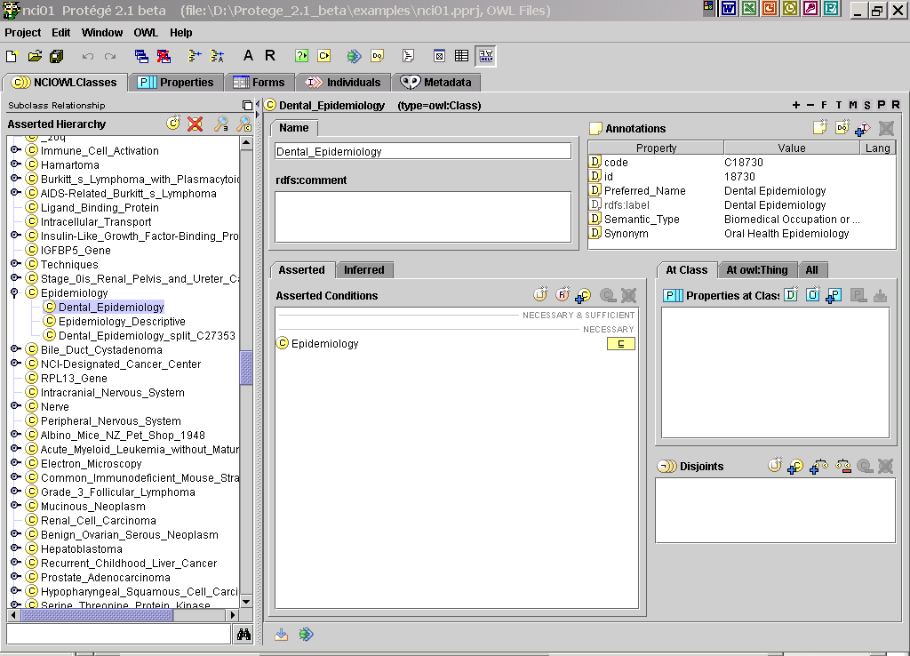

Step 8. To test the Merge function, you would have to specify two classes involved in the Merge action. The one you would like to retire is called retiring class, and another one into which the retiring class would be merged is called surviving class. To illustrate, select Dental_Epidemiology_split_C27353 as the retiring class. Click on the Merge (M) icon. The following Merge dialog box will appear.

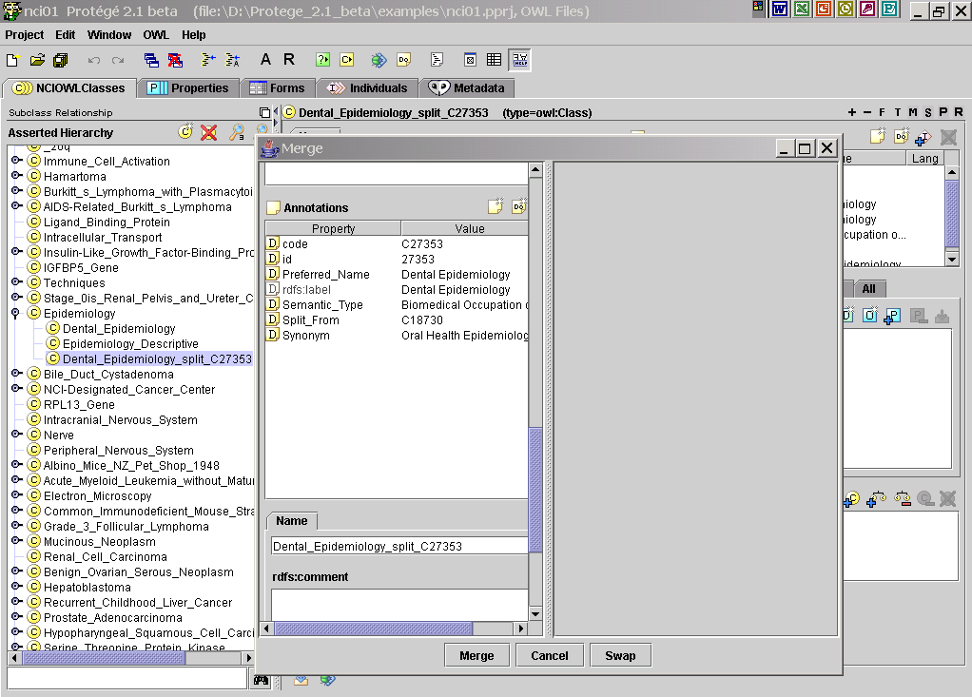

Next position the two windows properly so when you set focus on the main Protégé window, you can see both the main window and the Merge dialog box, as shown below.

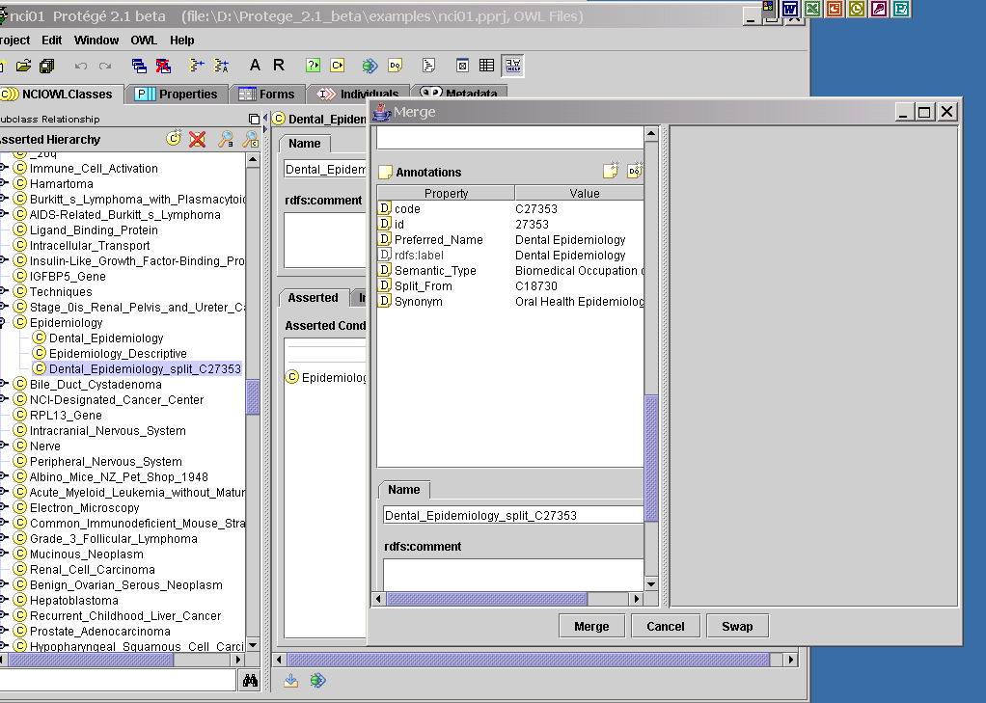

Select the surviving class Dental_Epidemiology from the taxonomy tree. The Merge dialog box supports drag and drop. So, drag Dental_Epidemiology from the taxonomy tree and drop it into the right pane of the Merge dialog box. The Merge dialog box will be populated with data belonging to both the surviving and the retiring classes. Use the Swap button to exchange the role of these two classes, i.e., to make the surviving class the retiring class and vise versa, if deemed necessary.

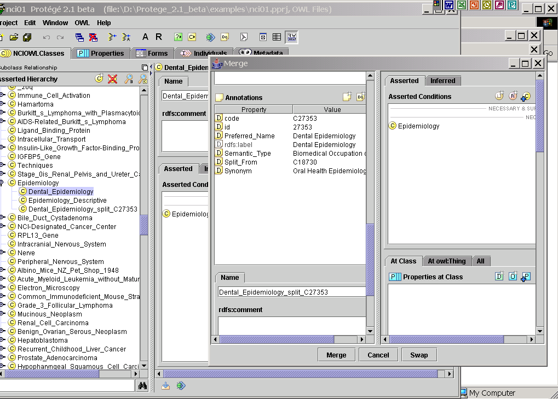

Press the Merge button to merge the retiring class (Dental_Epidemiology_split_C27353) into the surviving class (Dental_Epidemiology). Or, press Cancel to close the Merge dialog box. When you press the Merge button, the retiring class will be tagged as deprecated (a red icon will appear to the upper right corner of the retired class) as shown in the figure below. Checking for whether the pre-conditions have been met for the retiring class has not yet been implemented.

Step 9. To test the Pre-Retire function, first select the class Stage_IV_Bladder_Adenocarcinoma from the taxonomy tree. All data for this class will appear to the right of the taxonomy tree as appearing in the figure below.

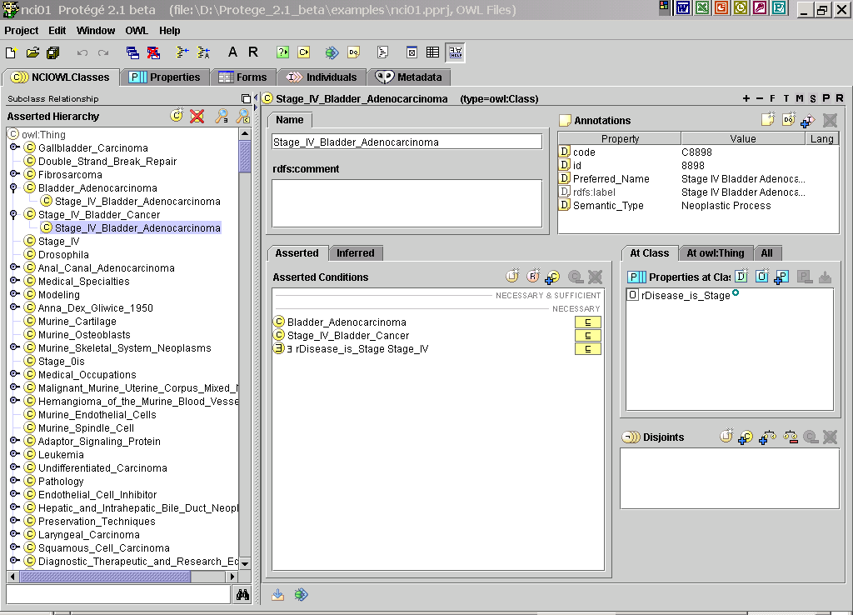

Note that Stage_IV_Bladder_Adenocarcinoma has a Some Restriction rDisease_is_Stage Stage with its filler value being Stage_IV. In DL language, this is equivalent to say that Stage_IV_Bladder_Adenocarcinoma is a role source and it has a role rDisease_is_Stage pointing to the role target Stage_IV. So, to retire Stage_IV, such restrictions would have to be either removed or modified. Now, select the class you would like to retire, say Stage_IV, and press the Pre-retire (P) icon. A Pre-retire dialog box as shown below will appear. The upper part of the dialog box will show the names of all subclasses of the retiring class (in this case, there is none) and the lower part of the dialog box will contain the names of all role sources (in this case, there is only one, which is Stage_IV_Bladder_Adenocarcinoma).

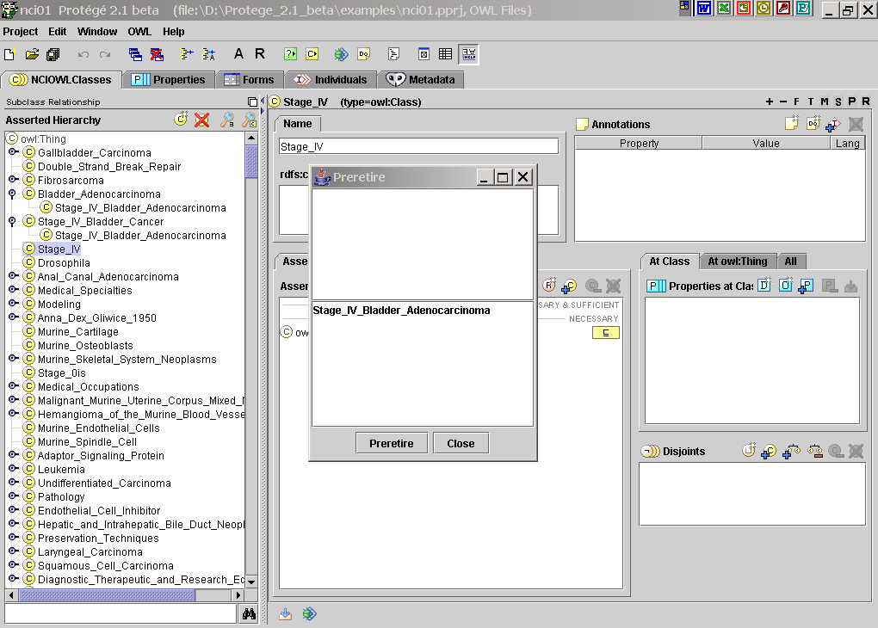

Now, double click on the list item, Stage_IV_Bladder_Adenocarcinoma. A Protégé Instance Dialog Box will appear. Select the Some Restriction from the Asserted Condition table and click on the Delete icon to remove this particular restriction from the Stage_IV_Bladder_Adenocarcinoma. Press the Done button to close the instance dialog box.
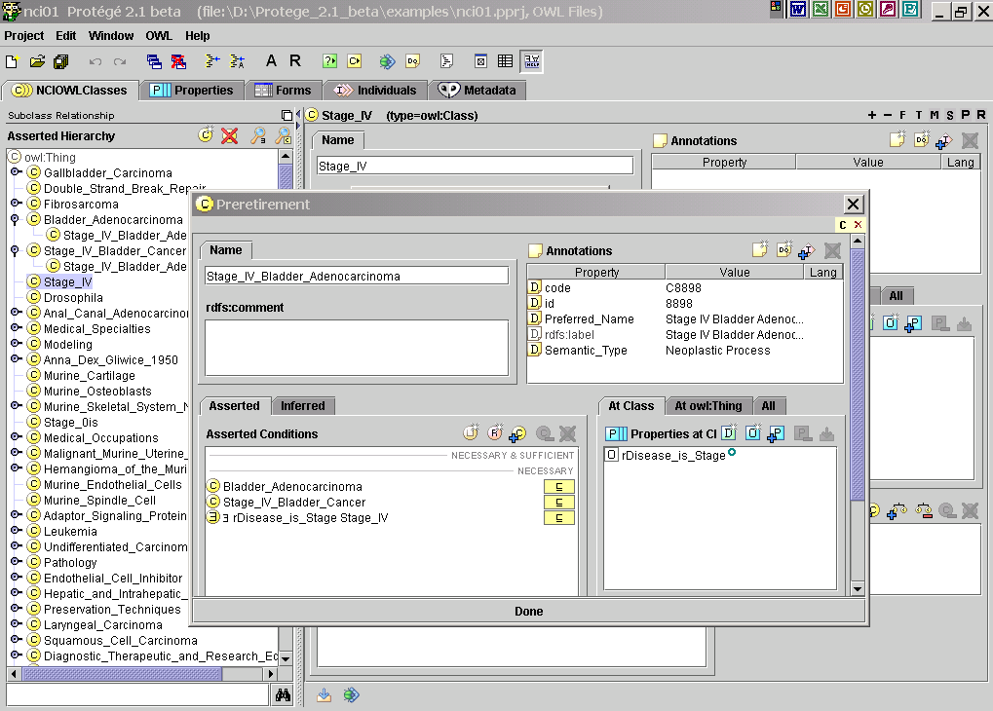

When you close the instance dialog box, you will notice that the font of Stage_IV_Bladder_Adenocarcinoma has been changed from regular to italic, indicating that the class Stage_IV_Bladder_Adenocarcinoma does not have a restriction with filler equaling Stage_IV any more and all pre-conditions for retirement have been met for Stage_IV.

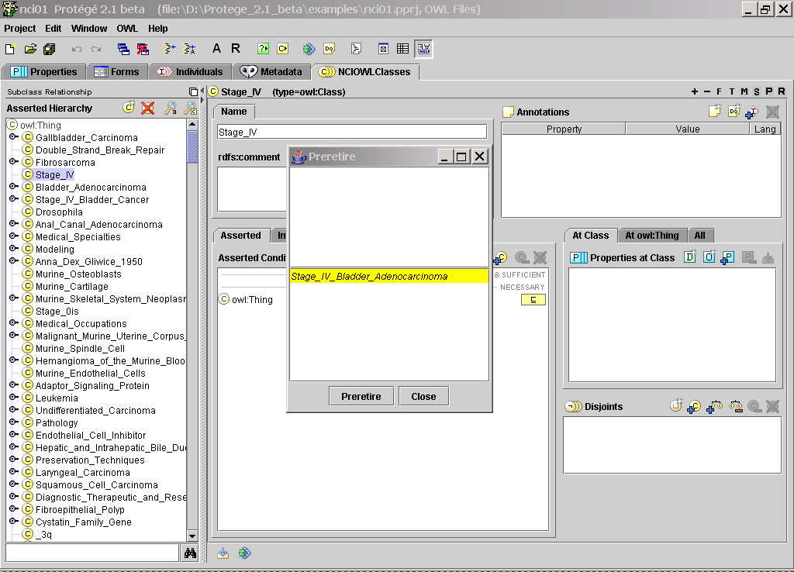

Press the Preretire button to continue, or press Close to close the Preretire dialog box. When you press the Preretire button, a confirmation dialog box as shown below will appear. Press Yes to continue, or press No to abort.

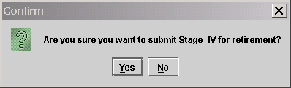

If you press Yes, the following message box will appear. Press OK to close this message box.
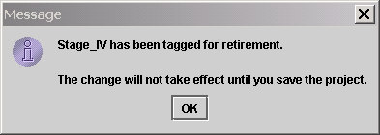

If the pre-retirement operation is successful, you should be able to find the retiring class in the taxonomy tree as a subclass of “Preretire_Classes”. This is just a placeholder for all preretired classes. Further modification would be done to put pre-retired classes into different bins based on their kinds.
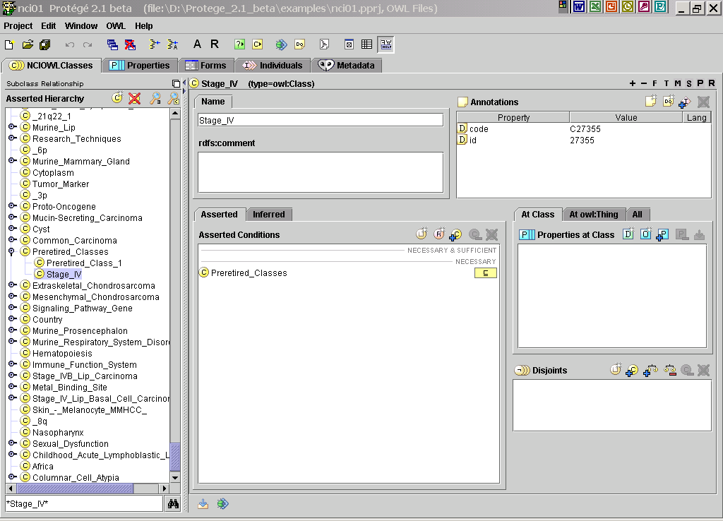

Step 10. To test the Retire function, click on the Retire (‘R”) icon. A Retire dialog box will appear, as shown below. Again, depending on the user privilege as defined in nci.properties, you may or may not see the icon.

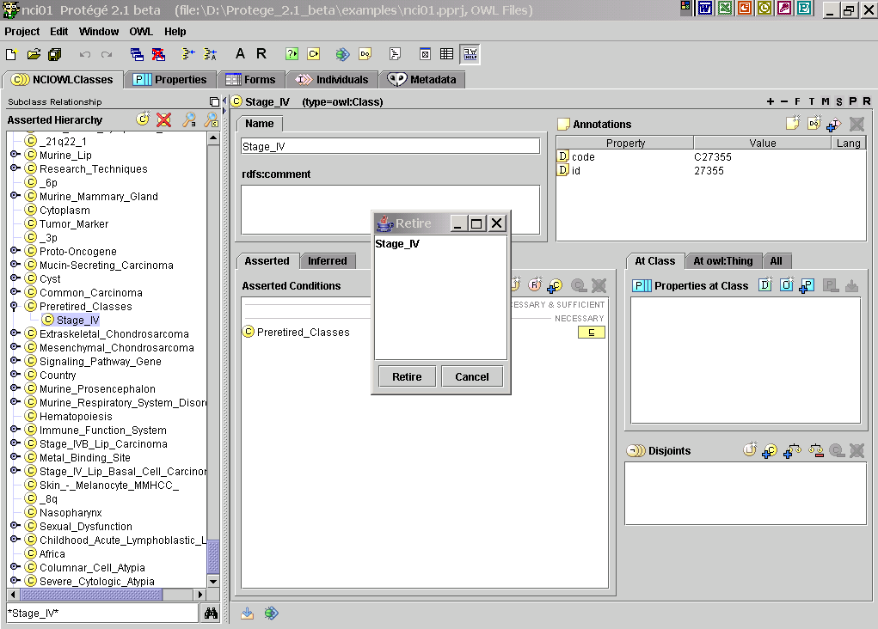

Select the class you would like to retire. Press the Retire button to retire the class, or press Cancel to abort. When you press the Retire button, the Retire dialog box will be closed. You should be able to find the retired class in the taxonomy tree under “Retired_Classes”. The retired class will have an icon (D) at the right upper corner of its name.

