(May 23, 2006 version, on ways to access
FDA and other subsets that are in NCI Thesaurus)

Table of Contents

Using the Report Writer
Using the Application Programming Interfaces (APIs)
Using the NCI Terminology Browser
Advanced Search
FDA_Table Property
FULL_SYN Property
Concept_In_Subset Association
Browse the Tree Hierarchy

The NCI Thesaurus contains a growing number of terminology subsets from the FDA, CDISC and other groups including:

- Patient codes
- Medical device components and accessories
- Routes of administration
- Package type
- Dosage form
- Individual Case Safety Report (ICSR)
- Unit of potency
- Structured Product Labeling Color
- Structured Product Labeling Shape
- Structured Product Labeling DEA Schedule

There are several ways of accessing the subset terminologies which include:

- Using the Report Writer
- Using the Application Programming Interfaces (APIs)
- Using the NCI Terminology Browser

Using the Report Writer

The Report Writer is a desktop java application that retrieves concept data from the production version of the NCI Thesaurus terminology. It is run from a console (i.e. DOS window), as opposed to a GUI (Graphical User Interface), and accepts input parameters from the command line.

The application file, named ReportWriter.zip, is available from the anonymous FTP site here: ftp://ftp1.nci.nih.gov/pub/cacore/EVS/fda/

The application will:
- Retrieve all concepts in any Subset
  - Concepts in every Subset will be identified by the Concept_In_Subset association.
  - The Report Writer application will retrieve a complete list of the available Subsets from the terminology server and display them.
  - From this list the user will choose the desired Subset
  - The Report Writer application will retrieve all of the concepts in the selected Subset and display them.
- The Report Writer application will generate a concept report for each of the concepts selected above, including:
  - Preferred Name
  - NCI Concept Code
  - Definition
  - Comment
- The detailed concept report will contain comma separated text, which is easily loaded into Excel and databases.

Additional details on how to install and run the Report Writer can be found in the ReadMe.txt file that is contained in the ReportWriter.zip download.

See Appendix I below for a list of current subsets (as of May 17, 2006).

Using the Application Programming Interfaces (APIs)

The most flexible way for software developers to access the FDA terms in the NCI Thesaurus is to use the application programming interfaces (APIs).

Programmers will find the required information in the:

- caCORE Technical Guide:
ftp://ftp1.nci.nih.gov/pub/cacore/caCORE2.0_Tech_Guide.pdf

- caCORE Technical Supplement:
ftp://ftp1.nci.nih.gov/pub/cacore/caCORE3.0.1_Tech_Supp.pdf

- Release notes: http://ncicb.nci.nih.gov/core/caCORE3.0.1_notes.txt

The client side APIs and JavaDocs are available for download here:
http://ncicb.nci.nih.gov/download/downloadcabio.jsp

Technical support is also provided at: http://ncicbsupport.nci.nih.gov/sw/

Using the NCI Terminology Browser

The NCI Terminology Browser can also be used to access a subset terminology. However, there is a maximum display limit of 250 concepts. Therefore, this method is best used for subsets smaller than 250, or searching for specific, individual concepts.

The NCI Terminology Browser is located on the Web:

http://nciterms.nci.nih.gov/NCIBrowser/Dictionary.do

The NCI Thesaurus is already selected as the default on this page. To enter the search area:
- Click the Connect button at the bottom of the screen.

Current Retrieval Methods

There are currently two main ways to access subset terms within the Terminology Browser:

- Advanced Search
- Browse the Tree Hierarchy

Advanced Search

Using one of the following properties:

- FDA_Table
- FULL_SYN
- Concept_In_Subset

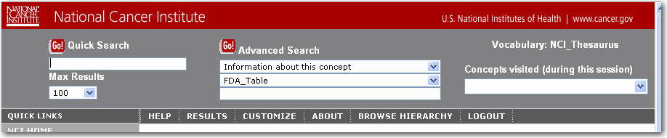

As you can see above, there are three drop-down lists under Advanced Search:

    - In the first box is the selection "Information about this concept". Leave that as the selection.
    - In the second box select FDA_Table or FULL_SYN from the drop-down list.
    - In the third box, enter the text or number you wish to retrieve.
    - When your search terms are entered, click the Go! button next to Advanced Search.

Searching the FDA_Table property:

- In the second drop-down box, choose FDA_Table
- In the third box, enter the full name of the concept you wish to retrieve.

For example: Patient Code (Appendix B)

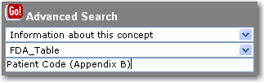

You can also use the wildcard character * along with part of the name of the concept you wish to retrieve.

For example: patient code*

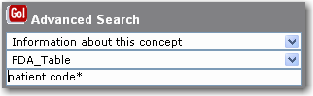

- After entering your search term(s), Click the Go! button.

NOTE: A maximum of 250 search results can be retrieved by using the Max Results drop-down list on the left-hand side of the page.

Searching the FULL_SYN property:

- In the second box, choose FULL_SYN
- In the third box, enter the search term or partial term with wildcard * that you wish to retrieve. You can use the wildcard on both the left and right of the partial search terms.

For example, to retrieve device component terms, enter: *device comp*

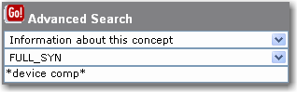

Or, to retrieve CDISC terms, enter: *cdisc*

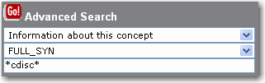

- After entering your search term(s), Click the Go! button.

NOTE: A maximum of 250 search results can be retrieved by using the Max Results drop-down list on the left-hand side of the page.

Searching the Concept_In_Subset association:

The Concept_In_Subset association will establish a semantic relation between the concept defining a particular subset and all concepts that are supposed to belong to this subset. This can be used by terminology subset owners and users to retrieve the list of the concepts that belong to a particular subset of terminology.

For example, the following subset exists as a concept in the NCI Thesaurus:

Medical_Device_Component_or_Accessory_Terminology

The full list of medical device components could then be retrieved by specifying the Medical_Device_Component_or_Accessory_Terminology_CDRH concept using the Concept_In_Subset association via the existing API or the Report Writer program.

The Advanced Search in the NCI Terminology Browser can also be used to retrieve this information:
- In the first drop-down box, choose Associations
- In the second drop-down box, choose Concept_In_Subset; and
- In the third box, enter all or part of the subset name you wish to retrieve.
For example: medical device component*

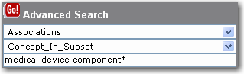

- After entering your search term(s), Click the Go! button.

The list of results shows the concepts that are in the Medical_Device_Component_or_Accessory_Terminology_CDRH subset.

Availability: The Concept_In_Subset association is available starting with the 06.04d version of the NCI Thesaurus.

NOTE: A maximum of 250 search results can be retrieved by using the Max Results drop-down list on the left-hand side of the page.

Browse the Tree Hierarchy

Another way to view specific terms within the vocabulary is to use the Browse Hierarchy option. This is a hierarchical display of all the concepts in the vocabulary.

To access the tree display:

- Click on the Browse Hierarchy button in the display (located underneath the Advanced Search area.)
- A separate window will open, showing the top-most concepts in each of the vocabulary’s main subdivisions.
- If you wanted to browse for certain types of equipment, for example, you would click on the plus sign next to the term Diagnostic, Therapeutic, and Research Equipment.

The tree would expand, and you would see a display that starts liked this:

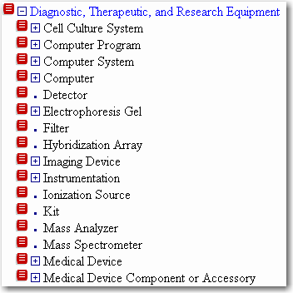

- To open up a full concept record in the main window, click on the red Concept Details icon to the left of the concept.
- Or, click on a plus sign in the hierarchy window to view terms further down in the hierarchy.

In the main window, the full concept record shows all of the details about a given concept including:
- Definition
- Synonyms
- Subconcepts
  - This section lists all of the concepts contained under the concept you are viewing. This is an alternate way to view what terms are contained in a given subset.
  - Keep in mind that a subconcept may have other concepts underneath it in the hierarchy that are not shown here. To view them, click on the concept details record next to a given subconcept, or browse the tree hierarchy to open up the terminology list further.

An example of a Concept Details screen appears on the next page.
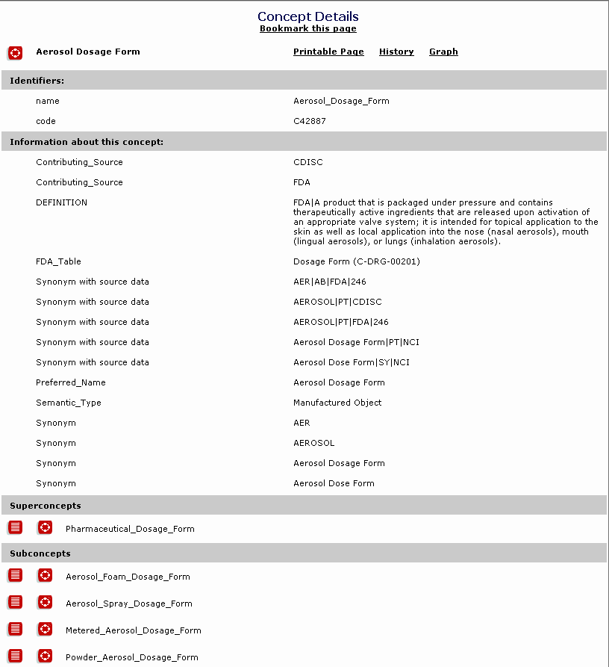

Appendix I

Terminology_Subset Concepts

The following is a listing of the concepts under the Terminology_Subset concept of the NCI Thesaurus. The numeric prefix is an indication of their tree placement. This listing was generated on May 17, 2006; the number of concepts in this branch of the NCI Thesaurus is expected to change/grow in future releases.

1 Individual_Case_Safety_Report_Terminology
1.1 Adverse_Event_Outcome_ICSR_Terminology
1.2 Device_Usage_ICSR_Terminology
1.3 Location_Of_Event_Occurrence_ICSR_Terminology
1.4 Occupation_ICSR_Terminology
1.5 Operator_of_Medical_Device_ICSR_Terminology
1.6 Reason_For_Non-Evaluation_ICSR_Terminology
1.7 Report_Source_ICSR_Terminology
1.8 Type_Of_Follow-Up_ICSR_Terminology
1.9 Type_Of_Manufacturer_ICSR_Terminology
1.10 Type_Of_Remedial_Action_ICSR_Terminology
1.11 Type_Of_Report_ICSR_Terminology
1.12 Type_Of_Reporter_ICSR_Terminology
1.13 Type_of_Event_ICSR_Terminology
1.14 Type_of_Reportable_Event_ICSR_Terminology
2 Medical_Device_Component_Or_Accessory_Terminology_CDRH
3 Medical_Device_Problem_Codes_FDA_CDRH
4 Patient_Problem_Codes_FDA_CDRH
5 Structured_Product_Labeling_Terminology
5.1 Limitation_Of_Use_Structured_Product_Labeling_Terminology
5.2 Pharmacokinetic_Effect_Consequences_Structured_Product_Labeling_Terminology
5.3 Structured_Product_Labeling_Color_Terminology
5.4 Structured_Product_Labeling_DEA_Schedule_Terminology
5.5 Structured_Product_Labeling_Drug_Route_of_Administration_Terminology
5.6 Structured_Product_Labeling_Medical_Product_Intent_Of_Use_Terminology
5.7 Structured_Product_Labeling_Package_Type_Terminology
5.8 Structured_Product_Labeling_Pharmaceutical_Dosage_Form_Terminology
5.9 Structured_Product_Labeling_Potency_Terminology
5.10 Structured_Product_Labeling_Shape_Terminology
5.11 Structured_Product_Labeling_Type_Of_Drug_Interaction_Consequence_Terminology

